Washington Iris Club
and Greater St. Louis Iris Society
(American Iris Society Affiliates)
Present
"On Fire for Irises"
IRIS SHOW
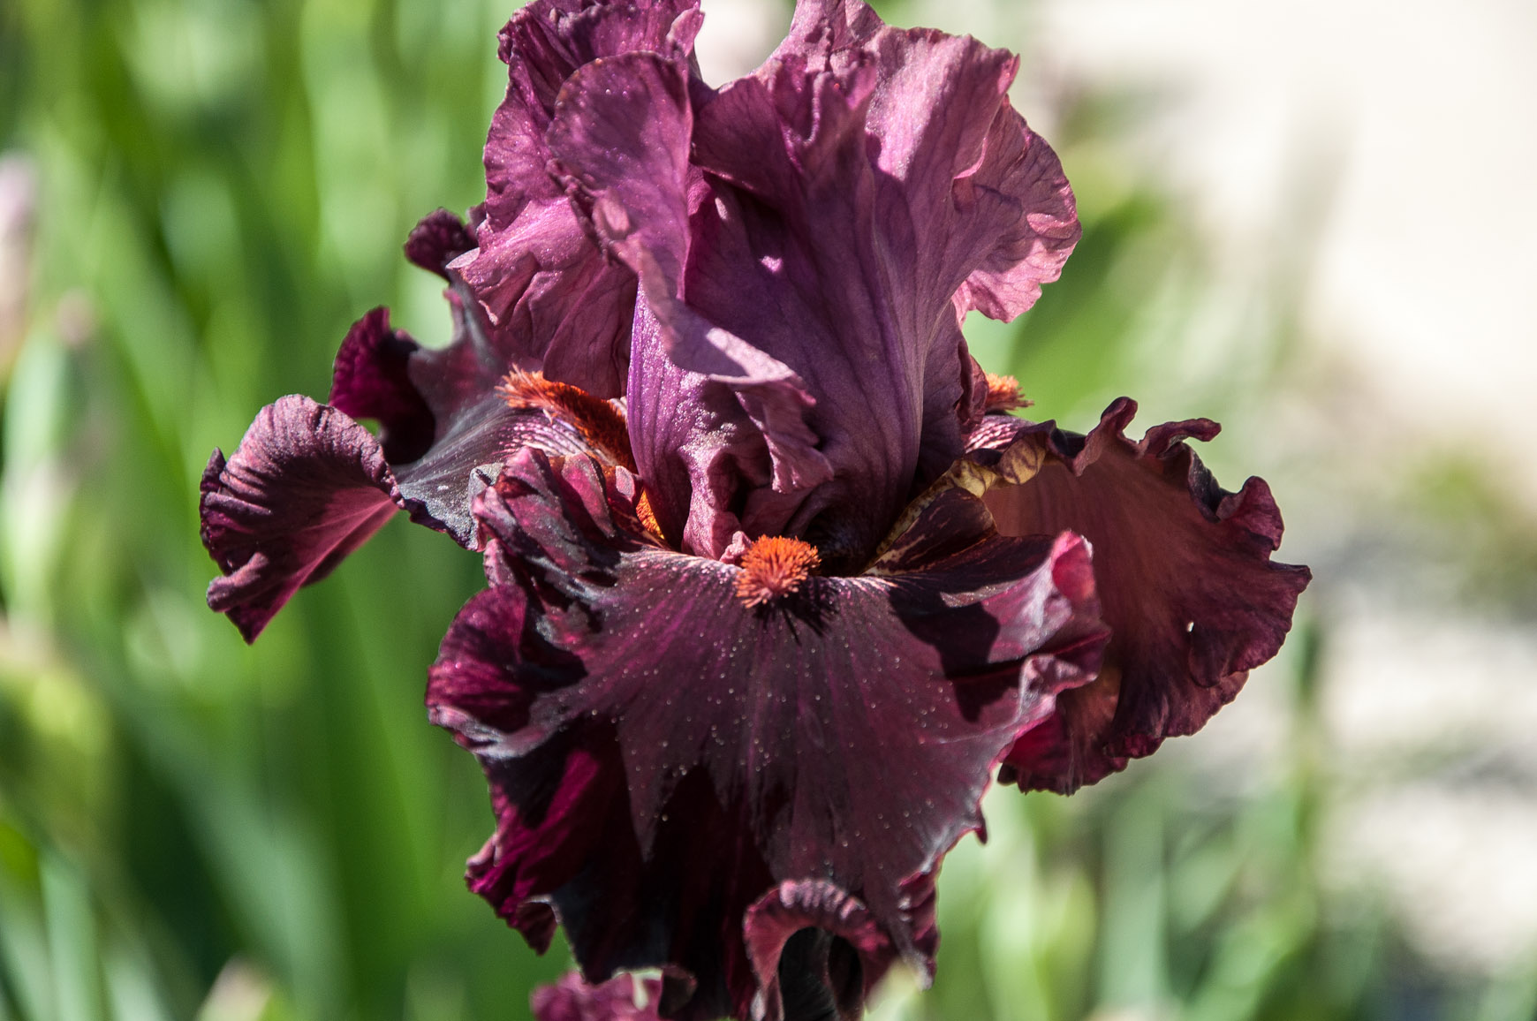
Saturday May 10, 2014

New Haven/Berger Fire Protection District Station #1
FREE ADMISSION
103 Dwayne Von Behren Drive
New Haven, MO 63068

Entries accepted from 7 a.m. to 9:30 a.m.

Open to the public from noon to 4 p.m.

WASHINGTON IRIS CLUB & GSLIS PRESENT
“On Fire for Irises”

Show Chairperson Cindy Rust (636) 583-2745
Show Co-Chairperson Carol Kuhlmann (573) 237-2061
Youth Chairperson Bernie Pennington (573) 484-4291
Design Committee Bernie Pennington (573) 484-4291

Registration of Entries Jim Morris
Horticultural Classification Barb Fouts, Jim Morris
Horticultural Clerks Open

Design Classification Bernie Pennington
Design Clerks Open
Hostesses Linda King, Barb Fouts
Secretary & Awards Bernie Pennington, Cindy Rust
Queen’s Table Barb Fouts, Bernie Pennington

Hospitality All Members
Property Clerks Volunteer Members
Publicity Luella Pehle, Bernie Pennington
Staging & Dismantling All Members

INTERESTED IN LEARNING ABOUT IRIS? JOIN THE WASHINGTON IRIS CLUB

Meetings are every other month for Fun, Food, Friendship and information about Irises.
Guests are always welcome. ANNUAL DUES: Adults $5.00 (over 70 free), Youth $2.00 (under 19), Family $7.00.

President – Bernie Pennington Vice-President – Cindy Rust
Secretary – Carol Kuhlmann Treasurer – Barb Fouts
Youth Chairperson – Bernie Pennington

YOU ARE INVITED TO JOIN THE AMERICAN IRIS SOCIETY
ANNUAL DUES: Single $25.00 Dual: $30.00
YOUTH (under 19) $9.00 with Bulletin $5.00 without Bulletin
Send check payable to: The American Iris Society
Tom Gormley, P.O. Box 177, DeLeon Springs, FL 32130

GENERAL RULES

1. This Iris Show has been approved by the American Iris Society and will be conducted according to its rules. We wish to extend our appreciation to the New Haven Fire District for the generous use of their facilities. We would also like to thank the East Central District of the Federated Garden Clubs of Missouri for their assistance in the design division of our show.

2. Accredited American Iris Society Judges will judge the Horticultural and Educational Divisions. Accredited Federated Garden Club judges will judge the Artistic Design Division. The decision of the judges will be final.

3. This Show is free and open to all gardeners. All competitive entries must be made in person, by individuals, not by schools (except for classroom iris projects), clubs or organizations. Judges may exhibit in the Show, but if judging this Show may not judge their own entries.

4. All entries must have been grown in the exhibitor’s own garden and must be his/her own property, except in the Artistic Division, and in the case of iris species collected from their wild habitat. The single-family garden is the exhibitor unit, except where family members grow iris independently.

5. All exhibitors must register and obtain an entry number, which must appear on all entry tag stubs. Standard AIS Entry Tags, provided by Washington Iris Club, must be used.

6. All entries will be received from 7:00 a.m. to 9:30 a.m. on the day of Show. Late entries and unidentified specimens may be displayed but not judged. Upon acceptance by the proper Classification Committee, exhibitors will place their exhibits on the Show Bench, in the proper Division, Section and Class and be out of the exhibition area by 9:45 a.m.

7. Judging will begin promptly at 10:00 a.m. During judging, only Judges, Clerks and Show Officials will be allowed in the area.

8. Exhibits and awards must remain in place until 4:00 p.m. and shall be removed by 5:00 p.m.

9. The Show Committee may combine or divide groups as entries warrant and may correct errors in entry, classification and identification of specimens.

10. The Washington Iris Club assumes no liability for damage to or loss of exhibits or personal property of exhibits and others, but will exercise every precaution to prevent such loss.

SHOW OPEN TO THE PUBLIC – NOON TO 4:00 P.M. – FREE ADMISSION!

The Certifying Official of Show shall have the judges to sign the Show Report upon completion of the judging.

SPECIAL RULES: HORTICULTURAL & SEEDLING DIVISIONS

DIVISION I – GENERAL HORTICULTURAL

- This is a Varietal (Cultivar) Show. A Varietal Show is one in which each individual named and introduced variety constitutes a separate class. Each Variety will be judged separately, on its own merits. Each exhibitor may enter only one specimen per variety, except in Collections. The exhibitor may enter as many varieties as desired.
- Each specimen (except for seedlings still under number) must be correctly named and must have been registered and introduced according to AIS regulations. The correct Division, Section and Classification (group or type) must be indicated on the entry tag, along with the varietal name. Entries will be placed in alphabetical order by Division, Section and Group.
- Transparent bottles, with little to no printing, shall be used for all single specimens except those with branching naturally occurring near ground level. Exhibitors shall provide their own containers.
- Bulbous Iris, Collections and English Boxes are not eligible to win Best Specimen of Show Award.

DIVISION II – SEEDLINGS

- A seedling is a cultivar, which may have been registered but not introduced. Any exhibitor may enter a seedling originated by another person, but the hybridizer’s name and the seedling number or registered name must appear on the entry tag along with the exhibitor’s name. The abbreviation SDLG must be written in red in front of the seedling number or name.
- Seedlings are not eligible to win Best Specimen of Show. Ribbons do not count towards Sweepstakes tally.

DIVISION III – YOUTH HORTICULTURE

- Exhibition privileges in the Youth Division are limited to persons under age 19. These exhibitors may enter in either Youth or General Horticulture, but not in both in the same Show. All General Horticultural Rules apply.
- Youth exhibitors may enter the Seedling Division and the Youth Horticultural Divisions in the same Show.

HORTICULTURAL AWARDS

AMERICAN IRIS SOCIETY AWARDS
(All exhibitors are eligible)

CLASS AWARDS - One First, one Second, one Third as many Honorable Mention ribbons may be given to each cultivar, if merited, except in the Seedling division.

BEST SPECIMEN OF SECTION - Small Rosette and AIS Certificate. (Requires 3 exhibitors and 5 cultivars for certificate to be awarded.)

BEST SPECIMEN OF SHOW - Large Rosette and AIS Certificate.

HORTICULTURAL SWEEPSTAKES - For the most Blue Ribbons in General Horticulture – Silver Medal, AIS Certificate and Large Rosette (provided there are at least 5 exhibitors and 20 cultivars.)

HORTICULTURAL SWEEPSTAKES RUNNER-UP - For the second highest number of Blue Ribbons – Bronze Medal and AIS Certificate.

HORTICULTURAL SWEEPSTAKES / YOUTH DIVISION - Silver medal, AIS Certificate and Small Rosette (provided there are at least 2 exhibitors and 10 cultivars.)

HORTICULTURAL SWEEPSTAKES RUNNER-UP / YOUTH DIVISION -
Bronze Medal and AIS Certificate.

BEST SEEDLING OF SHOW - Large Rosette and Exhibition AIS Certificate. An EC will be awarded to any seedling receiving 5 or more votes from accredited Judges attending the Show. Ballots will be provided.

BEST EDUCATIONAL EXHIBIT - AIS Certificate and Rosette.

NOTE: In the event of a tie for any Medal or AIS Certificate Award, Second Place Ribbons will be counted and if necessary, Third Place and Honorable Mention Ribbons. If still a tie, duplicate Silver Medals (and no Bronze) will be awarded. In the case of a Second Place tie, duplicate Bronze Medals will be awarded.

WASHINGTON IRIS CLUB AWARDS
(WIC members only)

BEST SPECIMEN OF SHOW – New iris from auction table; 1st Runner - Up $20 auction certificate; 2nd Runner - Up $15 auction certificate.

BEST ARTISTIC DESIGN – New iris from auction table; Artistic Sweepstakes Winner $20 auction certificate. SCHMIDT-KAMPSCHROEDER TROPHY for best design for Washington Iris Club members only. (Return for next show.)

SEEDLING TROPHY – (Washington Iris Club Members) – To the exhibitor of the Best Seedling, who will return it at the next Show.

GREATER ST. LOUIS IRIS SOCIETY AWARDS
(GSLIS members only)

RAY & DOROTHY PALMER AWARD is presented to the GSLIS member exhibiting the entry awarded Best Specimen at our Midseason “Regular” Show. (If overall show best specimen is won by non-GSLIS member, the Palmer Award will go to the highest ranking cultivar entered by a GSLIS member.) The show chairman will have to be alert to insure that this is determined by the judges.

JOSEPH C. BECHERER MEMORIAL TROPHY is awarded for Horticultural Sweepstakes to the GSLIS member winning the most blue ribbons at the GSLIS Mid-Season “Regular” Show.

“HYBRIDIZERS OF REGION 9 & 18 AWARD” normally designated for the Mid-Season “Regular” Show, this award goes to the Best Speciman displayed by a GSLIS member, which was hybridized by a Region 9 or Region 18 hybridizer.

SHELDON H. BUTT MEMORIAL AWARD is an award that transcends all GSLIS Shows in the year. It is awarded to the GSLIS member who wins the most median iris blue ribbons exhibited at all shows combined.

OVERALL SHOW AWARD
(All exhibiters are eligible)

BEST RED IRIS OF SHOW as determined by horticulture judges. The prize is a large red glass vase. Iris may be chosen from any horticultural section.

DIVISION I - GENERAL HORTICULTURE

Abbreviations of Classifications may be used on Entry Tags in spaces marked GROUP/CLASS, as follows.

SECTION A Miniature Dwarf Bearded MDB

SECTION B MEDIAN IRISES
Group 1 Standard Dwarf Bearded SDB
Group 2 Intermediate Bearded IB
Group 3 Miniature Tall Bearded MTB
Group 4 Border Bearded BB
Group 5 Aril & Aril Bred AR
Group 6 Novelty NOV
Group 7 Space Age SA

SECTION C TALL BEARDED
Group 1 Tall Bearded TB
Group 2 Novelty NOV
Group 3 Space Age SA

SECTION D OTHER BEARDED IRISES
Group 1 Aril & Aril Bred AR
Group 2 Bearded Species SPE

SECTION E BEARDLESS IRISES
Group 1 Siberian SIB
Group 2 Spuria SPU
Group 3 Louisiana LA
Group 4 Japanese JA
Group 5 Pacific Coast PCI
Group 6 Beardless Species SPE

SECTION F BULBOUS IRISES BU

SECTION G HISTORIC HIS
Any Iris introduced in 1984 or earlier. Must include year of introduction on entry tag. (Consult checklists at Registration Desk.)

SECTION H ENGLISH BOX
A minimum of five individual blooms of the same Classification-exhibitors choice.

SECTION I COLLECTIONS
Not eligible for Best Specimen of Show.
Group 1 Three stalks/one variety COL
Group 2 Three stalks/all different COL
Group 3 Five or more stalks/one variety COL
Group 4 Five or more stalks/all different COL

NOTE: Each individual specimen must be properly identified and labeled (in addition to the Entry Tag for the Box) in order to be eligible for AIS Awards.

DIVISION II - SEEDLINGS

SECTION A TALL BEARDED TB

SECTION B BEARDED, OTHER THAN TALL (Specify Classification)

SECTION C BEARDLESS (Specify Classification)

NOTE: The hybridizer’s name MUST appear on the entry tag, along with the Seedling number or Registered name. The abbreviation SDLG must be written in red before the number or name. Seedlings cannot have been introduced.

DIVISION III - YOUTH HORTICULTURE

This Division is limited to exhibitors under age 19.

The rules for General Horticulture will be used.

DIVISION IV - EDUCATIONAL EXHIBITS

All exhibits must relate to Iris, Iris Culture or Hybridizing.

SECTION A ADULT EDUCATIONAL EXHIBITS

SECTION B YOUTH EDUCATIONAL EXHIBITS
Class 1 Individual Exhibits
Class 2 Classroom Iris Projects

SPECIAL RULES – ARTISTIC DIVISION

One entry per class per exhibitor. Exhibitors may enter as many classes as desired. Arrangements must be the work of the person whose name appears on the entry tag.

At least one iris of any type must provide dominant interest in the design, unless otherwise specified.

Other flowers, foliage or fresh-cut plant material, rock, wood or natural materials
are permitted, except for bird nests. NO artificial flowers or foliage are permitted.
The exhibitor need not have grown Iris and other plant material.

Containers must be furnished by the exhibitor and must be clearly marked on the
bottoms with the exhibit’s name and address.

For more information, please call one of the Artistic Design Committee Members
listed on Page 1.

ARTISTIC DESIGN AWARDS

AMERICAN IRIS SOCIETY AWARDS (All exhibitors are eligible.)

CLASS AWARDS – One First, one Second, one Third and one Honorable Mention may be given per Class, if merited.

BEST DESIGN OF SECTION – Small Rosette.

BEST DESIGN OF SHOW – Large Rosette and AIS Certificate.

BEST DESIGN OF SHOW / YOUTH DIVISION – Small Rosette and AIS Certificate.

ARTISTIC SWEEPSTAKES – Large Rosette and AIS Certificate (for the most Blue Ribbons in the General or Novice Section.)

ARTISTIC SWEEPSTAKES / YOUTH DIVISION – Small Rosette and AIS Certificate (for the most Blue Ribbons in the Youth Division.)

NOTE: “Best Design of Show” MUST be awarded if at least one Blue Ribbon has been awarded in the Artistic Division.

DIVISION V - ARTISTIC DESIGN

“2014 Theme: “On Fire for Irises”

All sections use the same design classes.

SECTION I GENERAL - Open to all exhibitors.
SECTION II NOVICE – Open to those who have won one ribbon or less.
SECTION III YOUTH – Open to exhibitors under age 19 only.

Class 1 “The Fire House”
A design in an unusual container(s). Use your imagination.

Class 2 “Turn on the Hose”
A creative design of your choice.

Class 3 “The Fire House Dog”
Do I see spots?

Class 4 “Sliding Down the Pole”
A design showing motion.

Accessories permitted in all classes, unless otherwise stated in the class.

